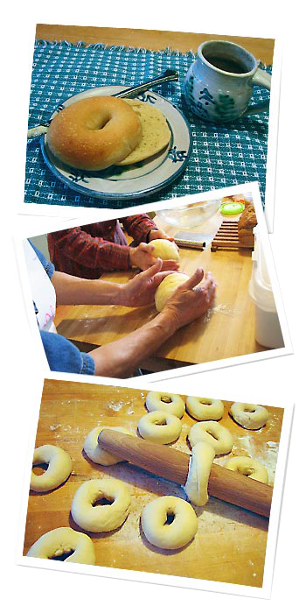

**EAGLES**

**BAKING CLASSES**

Total Baking Guide for you…

Starting from  
**MONDAY SEPTEMBER 06**  
from 06:00 PM -08:00 PM

**Baking Lessons are available for group of 4-8 persons in the evening…**

Contact us at:

Address line 1 address line 2  
phone: 555-555-55555  
fax: 555-555-55555  
www.emailaddress.com