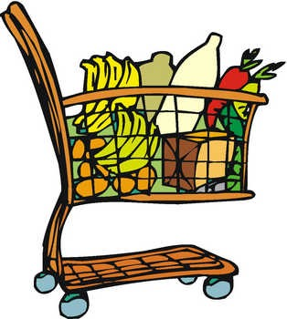

Grocery List Template

*This grocery list has been prepared for home shopping. It is better to have grocery shopping list with you when you go to market.*

|  |  |  |
| --- | --- | --- |
|  |  |  |
|  |  |  |
|  |  |  |
|  |  |  |
|  |  |  |
|  |  |  |
|  |  |  |
|  |  |  |
|  |  |  |
|  |  |  |
|  |  |  |
|  |  |  |
|  |  |  |
|  |  |  |
|  |  |  |
|  |  |  |
|  |  |  |
|  |  |  |
|  |  |  |
|  |  |  |
|  |  |  |
|  |  |  |
|  |  |  |
|  |  |  |
|  |  |  |
|  |  |  |
|  |  |  |
|  |  |  |
|  |  |  |

**GROCERY LIST**