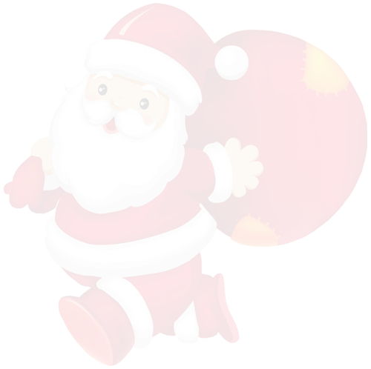

***Cute List Template***

|  |  |
| --- | --- |
|  | **Gift Name** |
|  |  |
|  |  |
|  |  |
|  |  |
|  |  |
|  |  |
|  |  |
|  |  |
|  |  |
|  |  |
|  |  |
|  |  |
|  |  |
|  |  |
|  |  |
|  |  |
|  |  |
|  |  |
|  |  |
|  |  |
|  |  |
|  |  |
|  |  |
|  |  |
|  |  |
|  |  |
|  |  |
|  |  |
|  |  |
|  |  |
|  |  |
|  |  |

|  |  |
| --- | --- |
|  | **Gift Name** |
|  |  |
|  |  |
|  |  |
|  |  |
|  |  |
|  |  |
|  |  |
|  |  |
|  |  |
|  |  |
|  |  |
|  |  |
|  |  |
|  |  |
|  |  |
|  |  |
|  |  |
|  |  |
|  |  |
|  |  |
|  |  |
|  |  |
|  |  |
|  |  |
|  |  |
|  |  |
|  |  |
|  |  |
|  |  |
|  |  |
|  |  |
|  |  |

**Merry Christmas**