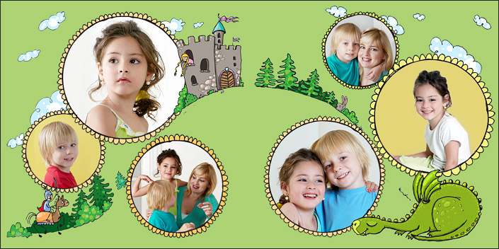

Kid’s Name: __________________________Date of Birth: ___________________________

**KIDS PHOTO ALBUM**



***CHANGE PICTURE***

***CHANGE PICTURE***

***CHANGE PICTURE***

***CHANGE PICTURE***

***CHANGE PICTURE***

***CHANGE PICTURE***