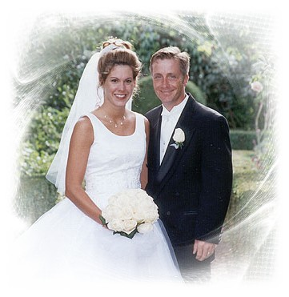

Wedding Card Template

**A happy marriage begins when you marry the one you love. They blossom when you love the one you marry. May your marriage continue to blossom from now to eternity…**

***CONGRATULATIONS TO THE HAPPY COUPLE***