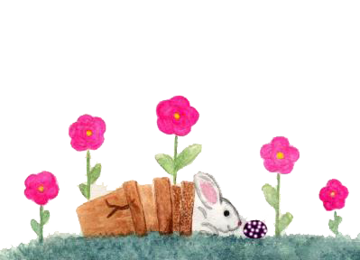

Greeting Card Template

**HAPPY EASTER!**

I wish you EASTER GREETING